
A. D. Patel Institute of Technology

LABORATORY MANUAL

Subject code: 3170724
Subject: Machine learning
Level: Fourth
Branch: Computer Engineering
Effective from: 21/6/2021

Table of Content
Sr. No | Experiment No. | Title | COs | Page No. | Remarks
1 | - | Table of content | - | 2
2 | - | Revision record sheet | - | 3
3 | - | Controlled copy holder | - | 4
4 | - | List of experiments | - | 2
 | 1 | Study of preprocessing methods – I | CO1 | 5
 | 2 | Study of preprocessing methods – II | CO1 | 6
 | 3 | Study and implement PCA in python | CO2 | 8
 | 4 | Study and implement simple linear and nonlinear regression method | CO2 | 11
 | 5 | Demonstrate the working of the decision tree-based ID3 algorithm | CO3 | 14
 | 6 | Implement the Naïve Bayesian classifier | CO3 | 16
 | 7 | Implement k-Nearest Neighbour algorithm to classify the iris data set | CO3 | 19
 | 8 | Implement and check Sklearn’s KFold, Shuffled Kfold, Repeated KFold and Leave One Out validation technique | CO4 | 20
 | 9 | Association rule mining | CO4 | 25
 | 10 | Build Artificial Neural Network and test the same | CO5 | 27

Revision record sheet
Sr. No. | Experiment No. | Name pf Experiment | Date of Revision | Page No.

Control copy holder
Sr. No | Experiment No. | Control copy | Revision No | Issue date
1 |  | Management Representative
2 |  | Head of the Department
3 |  | Course Coordinator

Practical 01
Study of preprocessing methods – I
Write a program to find following statistics from a given dataset. Mean, mode, median, variance, standard deviation, quartiles, interquartile range
Step 1 | import numpy as np  import pandas as pd  import statistics  stats=statistics
Step 2 | numbers=[12,45,6,89,14,56,78,9,74,9]
Step 3 | mean = stats.mean(numbers)  median = stats.median(numbers)  mode = stats.mode(numbers)  variance = stats.variance(numbers)  std = stats.stdev(numbers)  print(mean,median,mode,variance,std)
Step 4 | quartile_1 = np.median(numbers[:10])  quartile_1
Step 5 | quartile_3 = np.percentile(numbers, 75, interpolation = 'midpoint')  quartile_3
Step 6 | iqr = quartile_3 - quartile_1  iqr
Practical 02
Study of preprocessing methods – II
Study of data smoothing methods.
Write a program to perform data smoothing by
- binning with mean
- binning with boundary

Data binning, bucketing is a data pre-processing method used to minimize the effects of small observation errors. The original data values are divided into small intervals known as bins and then they are replaced by a general value calculated for that bin. This has a smoothing effect on the input data and may also reduce the chances of overfitting in the case of small datasets

In smoothing by bin means, each value in a bin is replaced by the mean value of the bin. In smoothing by bin boundaries, the minimum and maximum values in each bin are identified as the bin boundaries. Each bin value is then replaced by the closest boundary value.

Step 1 | from scipy import stats  import numpy as np
Step 2 | data = np.array([  10388.69, 10843.92, 10858.35, 10896.89, 12012.41, 12113.53,  12199.98, 12211.18, 12290.16, 12528.8 , 12649.4 , 12834.85,  13320.2 , 13520.01, 13591.3 , 13676.58, 13709.57, 13837.03,  13931.15, 14006.48, 14105.94, 14440.17, 14716.66, 14744.56,  14932.51, 15203.09, 15787.28, 15944.45, 20187.98, 21595.33])  bin1=np.zeros((10,3))  bin2=np.zeros((10,3))
Step 3 | #bin with mean  for i in range (0,30,3):  k=int(i/3)  mean=(data[i] + data[i+1] + data[i+2])/3  for j in range(3):  bin1[k,j]=mean  print("Bin Mean",bin1)
 | 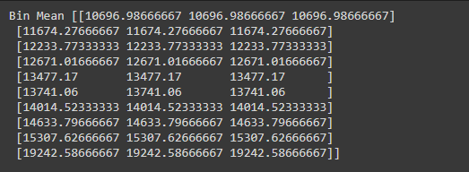
Step 4 | #bin with boundaries  for i in range (0,30,3):  k=int(i/3)  for j in range(3):  if (data[i+j] - data[i]) < (data[i+2]-data[i+j]):  bin2[k,j]=data[i]  else:  bin2[k,j]=data[i+2]  print("Bin Boundaries: \n",bin2)
 | 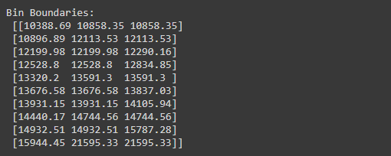

Practical 03
Study and implement PCA in python.
Principal Component Analysis, or PCA, is a dimensionality-reduction method that is often used to reduce the dimensionality of large data sets, by transforming a large set of variables into a smaller one that still contains most of the information in the large set.
Reducing the number of variables of a data set naturally comes at the expense of accuracy, but the trick in dimensionality reduction is to trade a little accuracy for simplicity. Because smaller data sets are easier to explore and visualize and make analyzing data much easier and faster for machine learning algorithms without extraneous variables to process.
So to sum up, the idea of PCA is simple — reduce the number of variables of a data set, while preserving as much information as possible.

Step 1 | import pandas as pd  url = "https://archive.ics.uci.edu/ml/machine-learning-databases/iris/iris.data"  # load dataset into Pandas DataFrame  df = pd.read_csv(url, names=['sepal length','sepal width','petal length','petal width','target'])  df.head()
 | 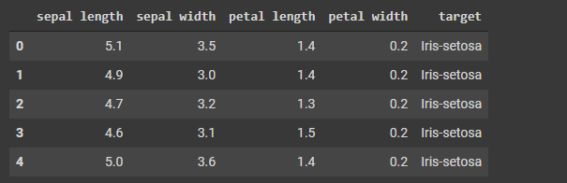
Step 2 | from sklearn.preprocessing import StandardScaler  features = ['sepal length', 'sepal width', 'petal length', 'petal width']  # Separating out the features  x = df.loc[:, features].values  # Separating out the target  y = df.loc[:,['target']].values  # Standardizing the features  x = StandardScaler().fit_transform(x)  pd.DataFrame(x).head()
 | 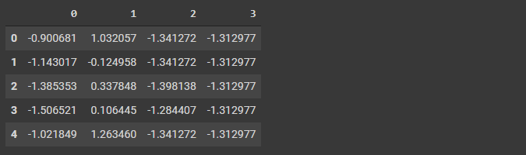
Step 3 | from sklearn.decomposition import PCA  pca = PCA(n_components=2)  principalComponents = pca.fit_transform(x)  principalDf = pd.DataFrame(data = principalComponents  , columns = ['principal component 1',  'principal component 2'])  principalDf.head()
 | 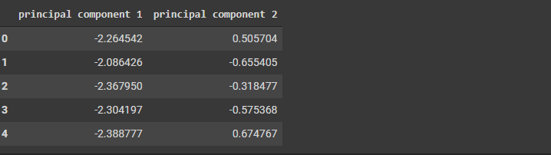
Step 4 | finalDf = pd.concat([principalDf, df[['target']]], axis = 1)  finalDf.head()
 | 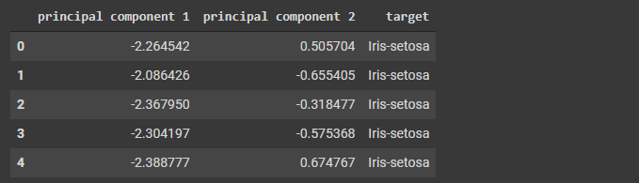

Practical 04
Study and implement simple linear and nonlinear regression method
Nonlinear regression is a form of regression analysis in which data is fit to a model and then expressed as a mathematical function. Simple linear regression relates two variables (X and Y) with a straight line (y = mx + b), while nonlinear regression relates the two variables in a nonlinear (curved) relationship.
Linear Regression:
Step 1 | import pandas as pd  import matplotlib.pyplot as plt  import numpy as np
Step 2 | df = pd.read_csv("/content/Salary_Data.csv")
Step 3 | x = df.iloc[:,0].values.reshape(-1,1)  y = df.iloc[:,1].values  from sklearn.linear_model import LinearRegression  Lin = LinearRegression()
Step 4 | Lin.fit(x, y)
Step 5 | pred_y = Lin.predict(x)
Step 6 | Lin.score(x,pred_y)
Step 7 | x = np.arange(-5.0, 5.0, 0.1)
Step 8 | y = 2*(x) + 3  y_noise = 2 * np.random.normal(size = x.size)  ydata = y + y_noise  plt.plot(x, ydata, 'bo')  plt.plot(x, y, 'r')  plt.ylabel('Dependent Variable')  plt.xlabel('Independent Variable')  plt.show()
 | 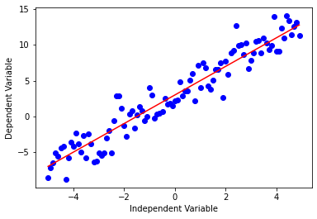

Non-linear Regression:
Step 1 | import pandas as pd  import numpy as np  xdic={'X': {11: 300, 12: 170, 13: 288, 14: 360, 15: 319, 16: 330, 17: 520, 18: 345, 19: 399, 20: 479}}  ydic={'y': {11: 305000, 12: 270000, 13: 360000, 14: 370000, 15: 379000, 16: 405000, 17: 407500, 18: 450000, 19: 450000, 20: 485000}}  X = pd.DataFrame.from_dict(xdic)  Y = pd.DataFrame.from_dict(ydic)  X_seq = np.linspace(X.min(),X.max(),300).reshape(-1,1)  X_seq[:5]
 | 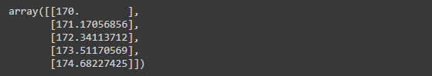
Step 2 | from sklearn.preprocessing import PolynomialFeatures  from sklearn.pipeline import make_pipeline  from sklearn.linear_model import LinearRegression  degree=9  polyreg=make_pipeline(PolynomialFeatures(degree),LinearRegression())  polyreg.fit(X,y)
 | 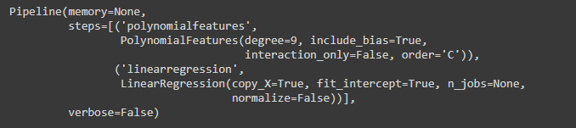
Step 3 | import matplotlib.pyplot as plt  plt.figure()  plt.scatter(X,y)  plt.plot(X_seq,polyreg.predict(X_seq),color="black")  plt.title("Polynomial regression with degree "+str(degree))  plt.show()
 | 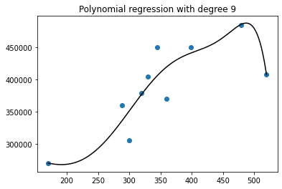
Practical 05
Write a program to demonstrate the working of the decision tree-based ID3 algorithm. Use an appropriate data set for building the decision tree and apply this knowledge to classify a new sample.
Decision Trees (DTs) are a non-parametric supervised learning method used for classification and regression. The goal is to create a model that predicts the value of a target variable by learning simple decision rules inferred from the data features. A tree can be seen as a piecewise constant approximation.
Step 1 | import pandas as pd  from sklearn.tree import DecisionTreeClassifier  from sklearn.model_selection import train_test_split  from sklearn import metrics
Step 2 | col_names = ['pregnant', 'glucose', 'bp', 'skin', 'insulin', 'bmi', 'pedigree', 'age', 'label']  pima = pd.read_csv("diabetes.csv", header=None, names=col_names)  pima.head()
 | 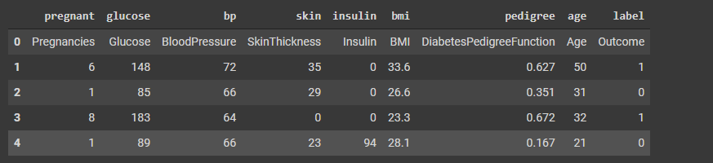
Step 3 | feature_cols = ['pregnant', 'insulin', 'bmi', 'age', 'glucose', 'bp','pedigree']  X = pima[feature_cols] # Features  y = pima.label # Target variable
Step 4 | X_train, X_test, y_train, y_test = train_test_split(X, y, test_size=0.3, random_state=1)  X_test = X_test[pd.to_numeric(X_test['pregnant'], errors='coerce').notnull()]
Step 5 | # Create Decision Tree classifer object  clf = DecisionTreeClassifier()  # Train Decision Tree Classifer  clf = clf.fit(X_train,y_train)  #Predict the response for test dataset  y_pred = clf.predict(X_test)
Step 6 | print("Accuracy:",metrics.accuracy_score(y_test, y_pred))
Step 7 | from sklearn.tree import export_graphviz  from sklearn.externals.six import StringIO  from IPython.display import Image  import pydotplus  dot_data = StringIO()  export_graphviz(clf, out_file=dot_data,  filled=True, rounded=True,  special_characters=True,feature_names = feature_cols,class_names=['0','1'])  graph = pydotplus.graph_from_dot_data(dot_data.getvalue())  graph.write_png('diabetes.png')  Image(graph.create_png())
 | 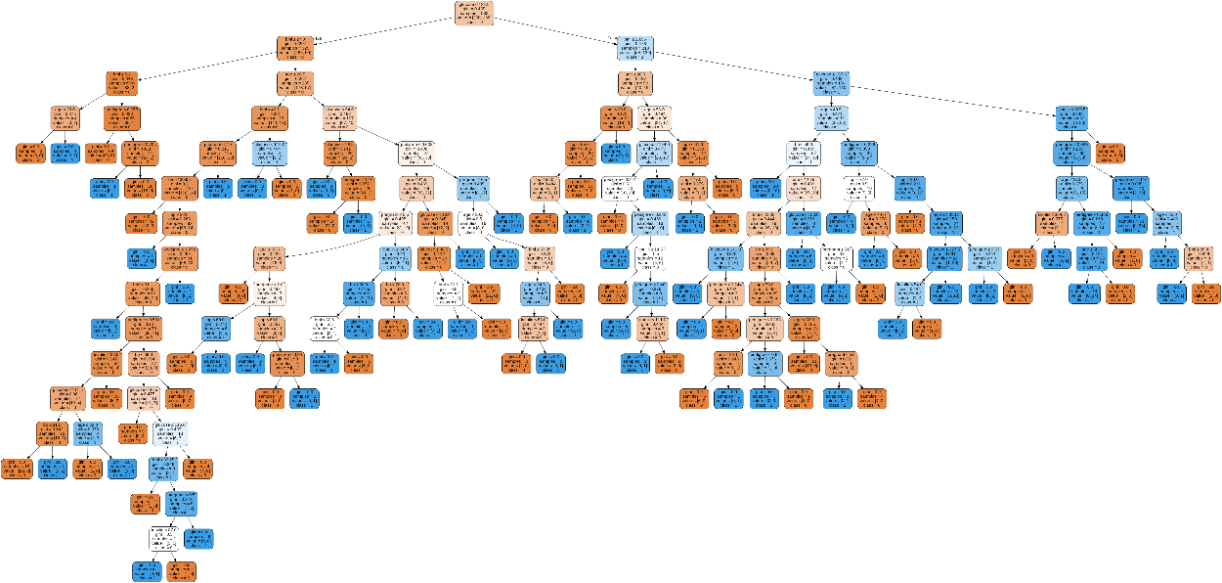
Practical 06
Write a program to implement the Naïve Bayesian classifier for a sample training data set stored as a .CSV file. Compute the accuracy of the classifier, considering few test data sets.
Step 1 | import numpy as np  import matplotlib.pyplot as plt  import pandas as pd
Step 2 | dataset = pd.read_csv('/content/Iris (1).csv')  X = dataset.iloc[:,:4].values  y = dataset['Species'].values  dataset.head(10)
 | 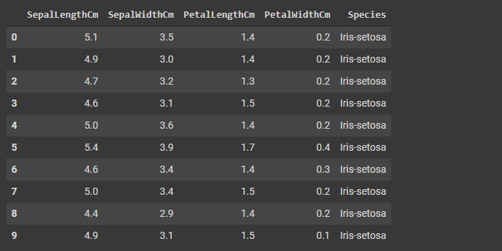
Step 3 | from sklearn.model_selection import train_test_split  X_train, X_test, y_train, y_test = train_test_split(X, y, test_size = 0.2)
Step 4 | from sklearn.preprocessing import StandardScaler  sc = StandardScaler()  X_train = sc.fit_transform(X_train)  X_test = sc.transform(X_test)
Step 5 | from sklearn.naive_bayes import BernoulliNB  classifier = BernoulliNB()  classifier.fit(X_train, y_train)
Step 6 | y_pred = classifier.predict(X_test)  y_pred
 | 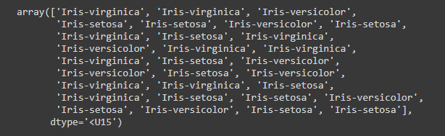
Step 7 | from sklearn.metrics import confusion_matrix  cm = confusion_matrix(y_test, y_pred)  from sklearn.metrics import accuracy_score  print ("Accuracy : ", accuracy_score(y_test, y_pred))  cm
 | 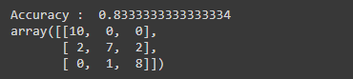
Step 8 | df = pd.DataFrame({'Real Values':y_test, 'Predicted Values':y_pred})  print(df)
 | 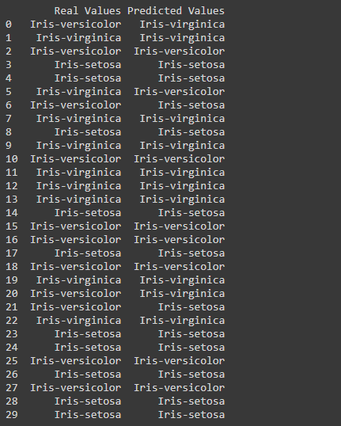

Practical 07
Write a program to implement k-Nearest Neighbour algorithm to classify the iris data set. Compute the accuracy of the classifier, considering few test data sets.
Step 1 | import numpy as np  import pandas as pd  import matplotlib  %matplotlib inline  import matplotlib.pyplot as plt  import seaborn as sns  from sklearn.datasets import load_iris  iris = load_iris()
Step 2 | df= pd.DataFrame(iris.data,columns=iris.feature_names)  df['target']= iris.target
Step 3 | x= df.drop(['target'],axis='columns')  y=df.target.values.reshape(-1,1)
Step 4 | from sklearn.model_selection import train_test_split  train_x,test_x,train_y,test_y= train_test_split(x,y, test_size=0.2)
Step 5 | from sklearn.neighbors import KNeighborsClassifier  knn=KNeighborsClassifier()
Step 6 | knn.fit(train_x,train_y)  pred_y=knn.predict(test_x)
Step 7 | from sklearn.metrics import accuracy_score, confusion_matrix  accuracy_score(test_y,pred_y)
Step 8 | confusion_matrix(test_y,pred_y)
 | 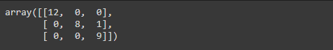

Practical 08
Write a program to implement and check Sklearn’s KFold, ShuffledKfold, RepeatedKFold and LeaveOneOut validation technique for appropriate classification algorithm and dataset.
Step 1 | import numpy as np  import pandas as pd  import matplotlib  %matplotlib inline  import matplotlib.pyplot as plt  import seaborn as sns  from sklearn.datasets import load_iris  iris = load_iris()
Step 2 | df= pd.DataFrame(iris.data,columns=iris.feature_names)  df['target']= iris.target
Step 3 | x= df.drop(['target'],axis='columns')  y=df.target
Step 4 | from sklearn.model_selection import train_test_split  train_x,test_x,train_y,test_y= train_test_split(x,y, test_size=0.2)
Step 5 | from sklearn.model_selection import train_test_split  train_x,test_x,train_y,test_y= train_test_split(x,y, test_size=0.2,random_state=2)
Step 6 | train_y.shape
Step 7 | from sklearn.neighbors import KNeighborsClassifier  knn=KNeighborsClassifier()
Step 8 | #KFold  from sklearn.model_selection import KFold  kf = KFold(n_splits=5)  kf.get_n_splits(x)  print(kf)  for train_index, test_index in kf.split(x):  print("TRAIN:", train_index, "TEST:", test_index)  train_x, test_x = x.iloc[train_index], x.iloc[test_index]  train_y, test_y = y.iloc[train_index], y.iloc[test_index]  knn.fit(train_x,train_y)  pred_y = knn.predict(test_x)  from sklearn.metrics import accuracy_score  accuracy_score(test_y,pred_y)
 | 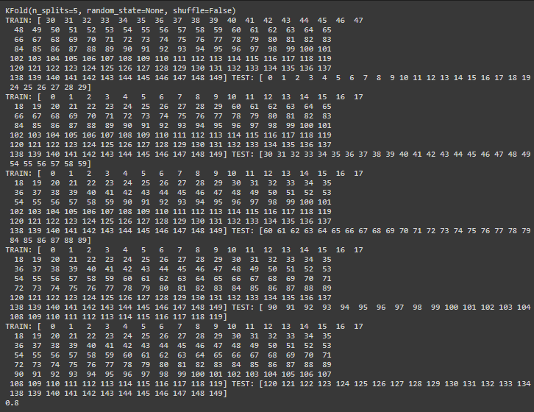
Step 9 | #Shuffled KFold  from sklearn.model_selection import KFold  kf = KFold(n_splits=3,shuffle=True,random_state=0)  kf.get_n_splits(x)  print(kf)  for train_index, test_index in kf.split(x):  print("TRAIN:", train_index, "TEST:", test_index)  train_x, test_x = x.iloc[train_index], x.iloc[test_index]  train_y, test_y = y.iloc[train_index], y.iloc[test_index]  knn.fit(train_x,train_y)  pred_y = knn.predict(test_x)  from sklearn.metrics import accuracy_score  accuracy_score(test_y,pred_y)
 | 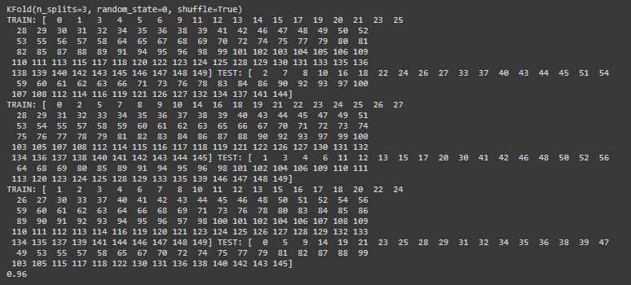
Step 10 | #RepeatedKfold  from sklearn.model_selection import RepeatedKFold  rk = RepeatedKFold(n_splits=2, n_repeats=2, random_state=10)  for train_index, test_index in rk.split(x):  print("TRAIN:", train_index, "TEST:", test_index)  train_x, test_x = x.iloc[train_index], x.iloc[test_index]  train_y, test_y = y.iloc[train_index], y.iloc[test_index]  knn.fit(train_x,train_y)  pred_y = knn.predict(test_x)  from sklearn.metrics import accuracy_score  accuracy_score(test_y,pred_y)
 | 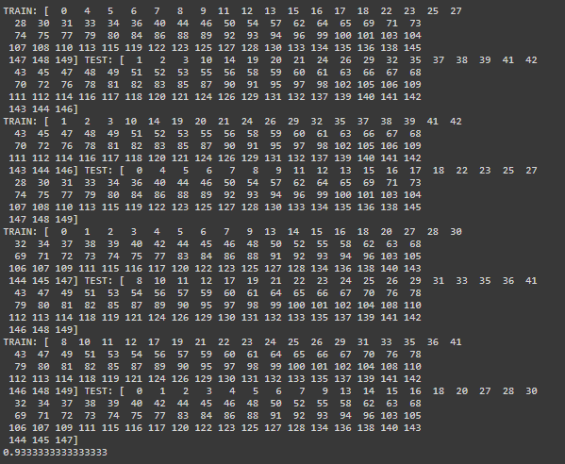
#LeaveOneOut
from sklearn.model_selection import LeaveOneOut
le = LeaveOneOut()
le.get_n_splits(x)
for train_index, test_index in le.split(x):
print("TRAIN:", train_index, "TEST:", test_index)
train_x, test_x = x.iloc[train_index], x.iloc[test_index]
train_y, test_y = y.iloc[train_index], y.iloc[test_index]
knn.fit(train_x,train_y)
pred_y = knn.predict(test_x)
from sklearn.metrics import accuracy_score
accuracy_score(test_y,pred_y)
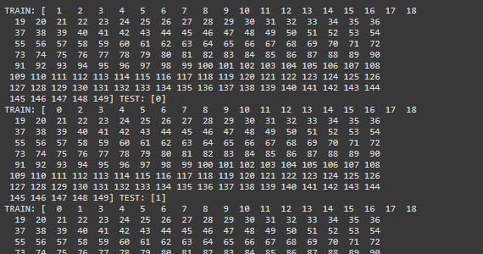
. . . .
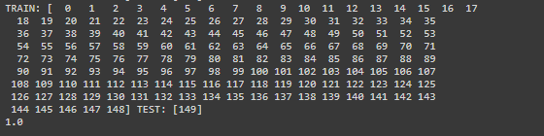

Practical 09
For the following dataset generate association rule
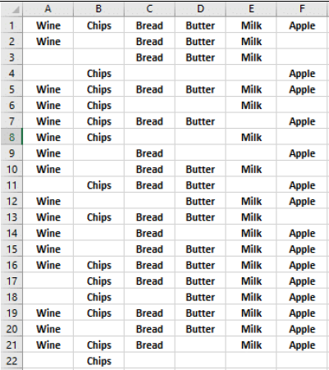
Step 1 | import numpy as np  import pandas as pd  !pip install apyori  from apyori import Apriori
Step 2 | df = pd.read_csv('https://raw.githubusercontent.com/HuynhHoa99/Aprio riAlgorithm/master/Day1.csv', header=None)  df.head(5)
 | 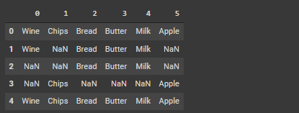
Step 3 | records = []  for i in range(22):  records.append([str(store_data.values[i, j]) for j in range(6)])
Step 4 | association_rules = apriori(records, min_support=0.5, min_confidence=0.7, min_lift=1.2, min_length=2)  association_results = list(association_rules)  print(association_results)
 | [RelationRecord(items=frozenset({'Bread', 'Butter', 'Milk'}), support=0.5, ordered_statistics=[OrderedStatistic(items_base= frozenset({'Butter'}), items_add=frozenset({'Bread', 'Milk'}), confidence=0.7333333333333334, lift=1.241025641025641), Ordered Statistic(items_base=frozenset({'Bread', 'Milk'}), items_add= frozenset({'Butter'}), confidence=0.8461538461538461, lift=1.241025641025641)])]

Practical 10
Write a program to build Artificial Neural Network and test the same using appropriate data sets.
Step 1 | import pandas as pd  import numpy as np  import matplotlib.pyplot as plt  %matplotlib inline  import tensorflow as tf  from tensorflow import keras
Step 2 | (train_x,train_y),(test_x,test_y)= keras.datasets.mnist.load_data()
Step 3 | len(train_x)
Step 4 | len(test_x)
Step 5 | plt.matshow(train_x[12])
 | 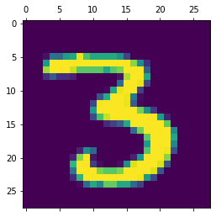
Step 6 | train_y[12]
Step 7 | flattened_train_x= train_x.reshape(len(train_x),28*28)  flattened_test_x=test_x.reshape(len(test_x),28*28)
from sklearn.preprocessing import StandardScaler
sc=StandardScaler()
flattened_train_x=sc.fit_transform(flattened_train_x)
flattened_test_x=sc.transform(flattened_test_x)
Step 8 | model = keras.Sequential([  keras.layers.Dense(500, input_shape=(784,), activation='relu'),  keras.layers.Dense(300, activation='relu'),  keras.layers.Dense(10, activation='sigmoid')  ])  model.compile(optimizer='adam', loss='sparse_categorical_crossentropy', metrics=['accuracy'])  model.fit(flattened_train_x,train_y,epochs=10)
 | 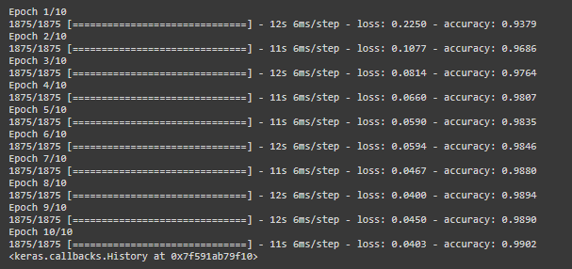
Step 9 | model.evaluate(flattened_test_x,test_y)

